Physical Electronics –
Minority Carriers

By: David Clarke
Course: Electrical & Electronic Engineering2
Date:24/3/2000

Abstract

Introduction

In the classic Haynes – Schottky experiment a bar of a semiconductor has ohmic contacts at either end and along its length are two rectifying contacts or pn junctions. An electric field is established along the bar and minority carriers are injected at one diode and drift in the direction in the direction of the second diode. The latter junction is reverse biased and as the injected minority carriers drift past it, some are collected, (in the same way that the collector functions in a transistor) and a current flows in the junction. If the dimensions of the sample and the drift time are measured, then the minority carrier drift mobility can be calculated. The effects of diffusion are apparent in the experiment and the diffusion constant can be calculated using the Einstein relation. It is also possible to estimate the lifetime of the excess minority carriers by measuring the variation in the number of minority carriers collected with drift time.

- Principles of Methods

1). Pulse the voltage across the silicon sample (else the sample becomes very hot and will be destroyed) and if the duty cycle is small there is little heating. A pulse width of about 4 μs and a pulse period of about 100 μs is okay. Do not exceed 5V until you are sure that a low duty cycle is established.
mA
PG
A1
E
C1-4
A2
470Ω
10KΩ
9V
Drift
Time

[Figure .1.]

2). To measure the mobility as outlined, the transit time is measured from the start of the pulse from the pulse generator to the centre of the minority carrier pulse. Select a single collector and use approximately a 10V pulse from A₁ to A₂.

3) If the experiment were carried out using a rectangular or uniform sectioned sample of silicon the electric field in the device would be uniform. We cannot assume this however. We need to measure a correction factor by which to multiply the apparent electric field. All that is necessary to put a known value pulse across the device (A₁ – A₂) and measure the potential difference between E and C₄ as indicated in Figure 3 and Figure 1. The silicon chip will just behave as a resistor. The problem is that you cannot measure the potential at E and C₄ because the diodes are reverse biased, so use the spare device and put a negative (-10 Volts) pulse across the sample. The diodes are now forward biased.

Results

CALCULATION OF THE CORRECTION FACTOR

Amplitude of the pulsed voltage V = 10 V
Length of Silicon sample L = 950 um

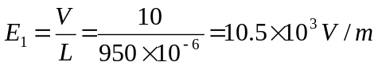

At 450um the potential of the sample with respect to ground equalled 4V

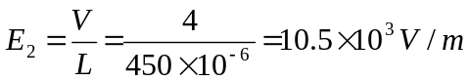

Hence the correction factor is:

Correction factor = 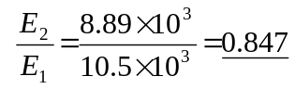

CALCULATION OF THE MINORITY CARRIER MOBILITY

Using Method 2

Rearrange the theory equation and plot a graph of “d” against “t” for a constant voltage pulse varying “d” by using the four collectors. Hence find the mobility.

Current | Collector C1 |  | Collector C2 |  | Collector C3 |  | Collector C4
(mA) | Voltage V | Time sec | Voltage V | Time sec | Voltage V | Time sec | Voltage V | Time sec
1.0 | 0.027 | 1E-6 | 0.0095 | 1.3E-6 | 0.0035 | 1.5E-6 | - | -
0.9 | 0.026 | 9.5E-7 | 0.0085 | 1.25E-6 | 0.003 | 1.48E-6 | - | -
0.7 | 0.022 | 9.25E-7 | 0.007 | 1.23E-6 | 0.0025 | 1.45E-6 | - | -
0.5 | 0.018 | 8.75E-7 | 0.0055 | 1.18E-6 | 0.0015 | 1.38E-6 | - | -
0.3 | 0.0125 | 8.25E-7 | 0.004 | 1.1E-6 | 0.0005 | 1.28E-6 | - | -
0.1 | 0.006 | 7.5E-7 | 0.0015 | 0.98E-6 | - | - | - | -

Distance from E to C1, C2, C3, C4 = 225, 300, 375μm respectively.

Plot of the minority carrier traverse time versus distance from emitter to each of the collectors for a current of 1.0mA.

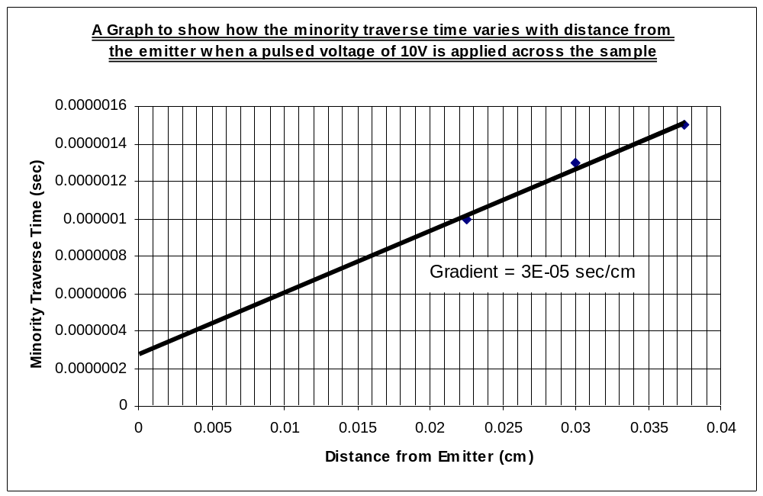
[Graph .1.]

Gradient of slope = 3.23E-5 sec/cm

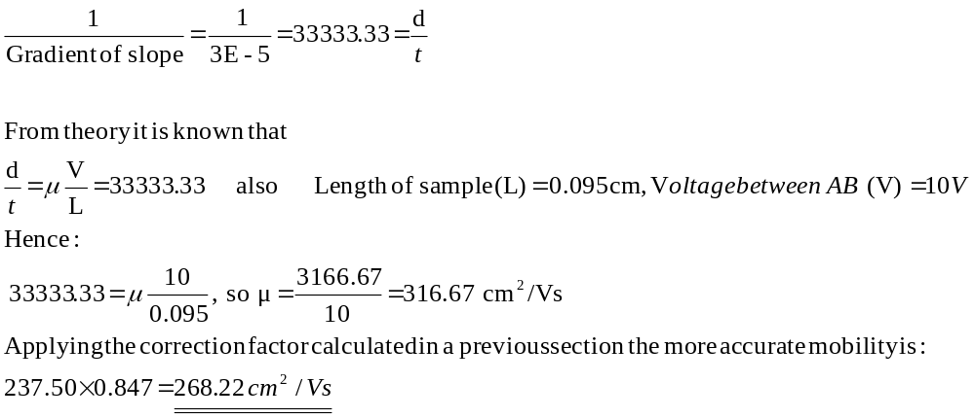

Plot of the minority carrier traverse time versus distance from emitter to each of the collectors for a current of 0.7mA.

[Graph .2.]

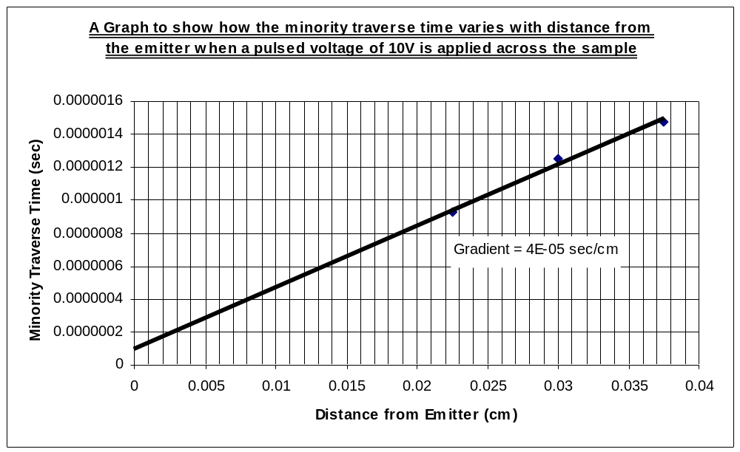
Gradient of slope = 3.73E-5 sec/cm

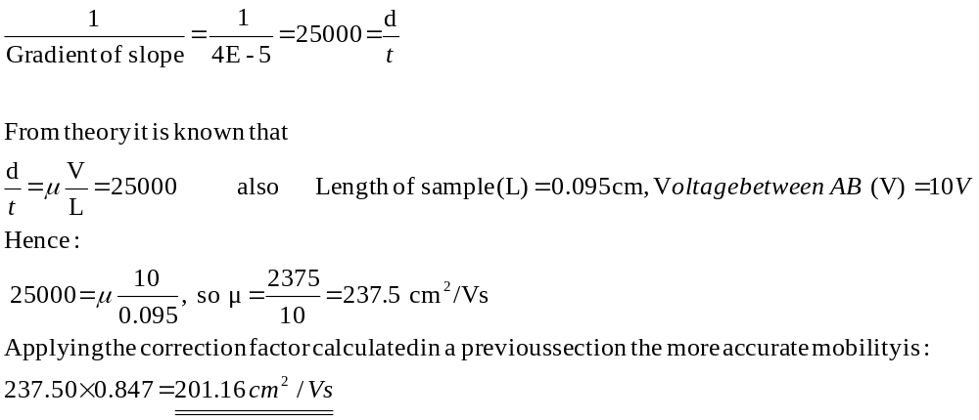

Plot of the minority carrier traverse time versus distance from emitter to each of the collectors for a current of 0.3mA.

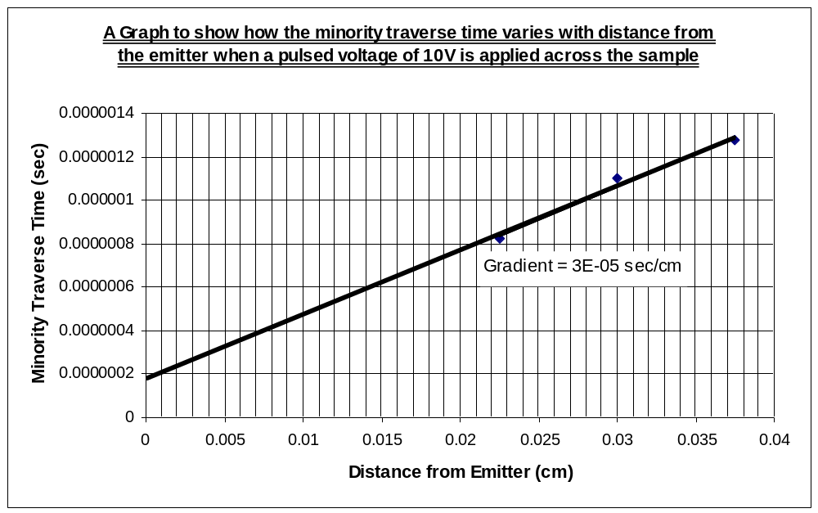[Graph .3.]

Gradient of slope = 2.96E-5 sec/cm

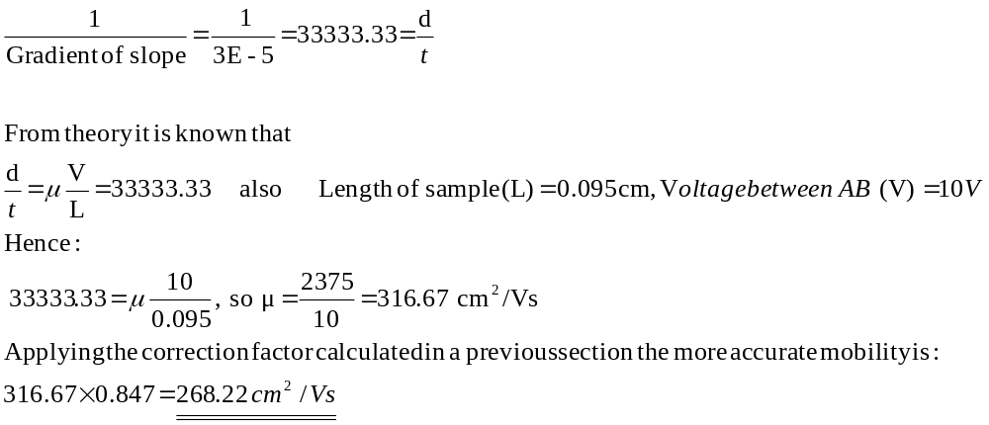

Comparison of the experimental mobility of the minority carriers with the actual mobility

Actual (book value) = 480 cm²/Vs (Mobility of exp should be around half this value)

[Graph .1.] emitter current of 1.0mA, mobility = 268.22 cm²/Vs
[Graph .2.] emitter current of 0.7mA, mobility = 201.16 cm²/Vs
[Graph .3.] emitter current of 0.3mA, mobility = 268.22 cm²/Vs

In [Table .1.] shown below, the mobility of the minority carriers has been tabulated for the whole range of emitter currents used. The average value of the mobility’s has been calculated and compared with the actual book value.

Emitter Current (mA) | Mobility (cm²/Vs)
1.0 | 268.22
0.9 | 201.16
0.7 | 201.16
0.5 | 268.22
0.3 | 268.22
0.1 | 268.22
Average experimental mobility | 245.87
Actual (book value) mobility | 480.00
Difference between the experimental and book value of mobility | 234.13
[Table.1.]

The table of results are graphically represented in [Graph .4.] below, this graph gives an indication of how the mobility of the minority carriers varies with applied emitter current.

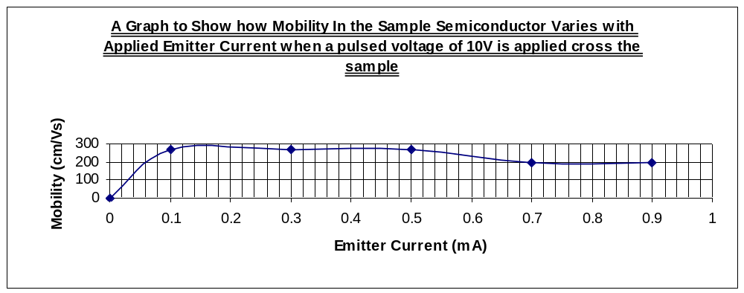[Graph .4.]

CALCULATION OF THE DIFFUSION COEFFICIENT

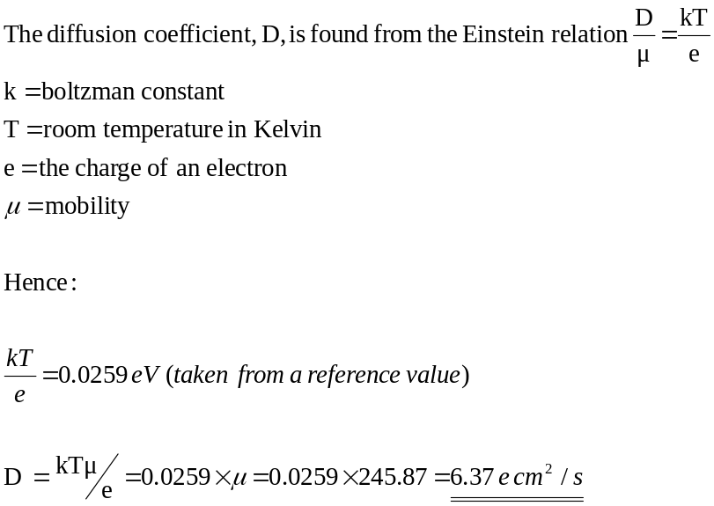

CALCULATION OF THE LIFETIME

- Discussion of Results and Conclusion

GENERAL OBSERVATIONS

Turn up the emitter current; why does the pulse shape distort?
?

Why does the carrier transit time seem to increase?

There are a lot more minority carriers (holes) produced at the emitter. Hence these holes populate a more widely dispersed area around the emitter. Hence the distance required for the average minority carrier to travel has increased, plus, with a greater number of minority carriers there are a greater number of collisions between neighbouring charges which will in effect increase the transit time.

Why does the pulse become relatively wider for larger transit times?

When larger transit times are faced by the minority carriers dispersion occurs due to the non-uniform electric field. Hence what can be seen at the collector is a pulse with a wider base but lower peak voltage, compared to a waveform of lower transit time origin.

